An Attribute-assisted Reranking Model for Web Image Search
ABSTRACT
- Image search Reranking is an effective approach to refine the text-based image search result. Most existing Reranking approaches are based on low-level visual features.
- exploit semantic attributes for image search Reranking. Based on the classifiers for all the predefined attributes, each image is represented by an attribute feature consisting of the responses from these classifiers. A hypergraph is then used to model the relationship between images by integrating low-level visual features and attribute features.
- Hypergraph ranking is then performed to order the images. Its basic principle is that visually similar images should have similar ranking scores. In this work, we propose a visual-attribute joint hypergraph learning approach to simultaneously explore two information sources.

EXISTING SYSTEM
- Image search Reranking is an effective approach to refine the text-based image search result. Most existing Reranking approaches are based on low-level visual features
- The existing visual Reranking methods can be typically categorized into three categories as the clustering based, classification based and graph based methods
Different from the existing methods, a hypergraph is then used to model the relationship between images by integrating low-level features and attribute features.
PROPOSED SYSTEM
proposed to refine text-based search results by exploiting the visual information contained in the images.
Graph based methods have been proposed recently and received increasing attention as demonstrated to be effective. The multimedia entities in top ranks and their visual relationship can be represented as a collection of nodes and edges.
After a query “baby” is submitted, an initial result is obtained via a text-based search engine. It is observed that text-based search often returns “inconsistent” results.
The experimental results demonstrate superiority of the proposed attribute-assisted reranking approach over other state-of-the-art reranking methods and their attribute-assisted variants.
Then the re-ranked result list is created first by ordering the clusters according to the cluster conditional probability and next by ordering the samples within a cluster based on their cluster membership value. In [24], a fast and accurate scheme is proposed for grouping Web image search results into semantic clusters. It is obvious that the clustering based reranking methods can work well when the initial search results contain many nearduplicate media documents.
proposed a semi-supervised framework to refine the text based image retrieval results via leveraging the data distribution and the partial supervision information obtained from the top ranked images

PROPOSED SYSTEM ALGORITHMS
- Intelligent clustering algorithms.
- Search Algorithm.

ADVANTAGES
The advantage of hypergraph can be summarized that not only does it take into account pair wise relationship between two vertices, but also higher order relationship among three or more vertices containing grouping information.
regularized logistic regression trained for each attribute within each class.
as attribute features are formed by prediction of several classifiers, semantic description of each image might be inaccurate and noisy

System Architecture

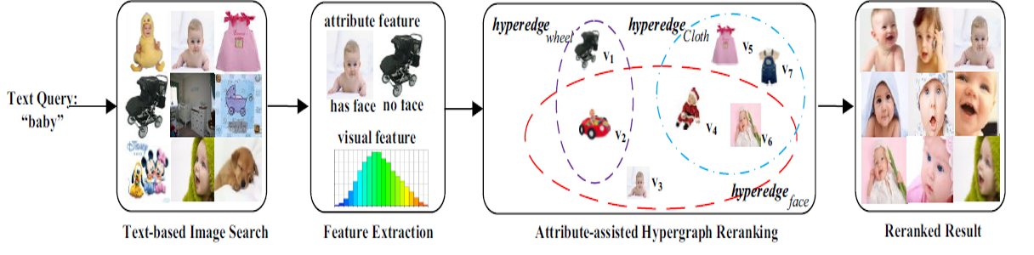
- The System and Threat Models
- Search,
- Hypergraph,
- Attribute-assisted,

MODULE DESCRIPTION
- Image search re ranking is an effective approach to refine the text-based image search result
- initial search results from text-based retrieval can be grouped by visual closeness
- In the classification based methods, visual re ranking is formulated as binary classification problem aiming to identify whether each search result is relevant or not.
- we propose to exploit stronger semantic relationship in the graph for image search re ranking.
- all these superiorities drive us to exploit semantic attributes for image representation in the task of web image search re ranking.
- Figure 1 illustrates the flowchart of our proposed method. After a query “baby” is submitted, an initial result is obtained via a text-based search engine.
- Web image search re ranking is emerging as one of the promising techniques for automotive boosting of retrieval precision.
- proposed attribute-assisted image search re ranking framework.

Hypergraph:
- A hypergraph is then used to model the relationship between images by integrating low-level visual features and attribute features.
- a visual-attribute joint hypergraph learning approach to simultaneously explore two information sources.
- Visual representation and semantic description are simultaneously exploited in a unified model called hypergraph.
- the selection of attribute features could be conducted simultaneously through the process of hypergraph learning such that the effects of semantic attributes could be further tapped and incorporated in the reranking framework.
- Compared with the previous method, a hypergraph is reconstructed to model the relationship of all the images, in which each vertex denotes an image and a hyperedge represents an attribute and a hyperedge connects to multiple vertices.
- The advantage of hypergraph can be summarized that not only does it take into account pairwise relationship between two vertices, but also higher order relationship among three or more vertices containing grouping information.
- a hypergraph is then used to model the relationship between images by integrating low-level features and attribute features.
- a hyperedge in a hypergraph is able to link more than two vertices

Attribute-assisted:
- we elaborate the proposed attribute-assisted image search re ranking framework.
- an attribute-assisted hypergraph learning method to reorder the ranked images which returned from search engine based on textual query.
- attribute-assisted re ranking method, we compare the following approaches for performance evaluation.
SYSTEM SPECIFICATION

Hardware Requirements:

- System : Pentium IV 3.4 GHz.
- Hard Disk : 40 GB.
- Monitor : 14’ Colour Monitor.
- Mouse : Optical Mouse.
- Ram : 1 GB.

Software Requirements:

- Operating system : Windows Family.
- Coding Language : J2EE (JSP,Servlet,Java Bean)
- Data Base : My Sql.
- IDE : Eclipse - Galileo
- Web Server : Tomcat 5.0/6.0
- Web Designing : Dream Viewe Documentation : MS Office

System Design:

