Privacy-Preserving Public Auditing for Secure Cloud Storage

ABSTRACT
Cloud computing is internet based computing which enables sharing of services. Many users place their data in the cloud. However, the fact that users no longer have physical possession of the possibly large size of outsourced data makes the data integrity protection in cloud computing a very challenging and potentially formida-ble task, especially for users with constrained computing resources and capabilities. So correctness of data and security is a prime concern. This article studies the problem of ensuring the integrity and security of data storage in Cloud Computing. Security in cloud is achieved by signing the data block before sending to the cloud. Using Cloud Storage, users can remotely store their data and enjoy the on-demand high quality applications and services from a shared pool of configurable computing resources, without the burden of local data storage and maintenance. However, the fact that users no longer have physical possession of the outsourced data makes the data integrity protection in Cloud Computing a formidable task, especially for users with constrained computing resources. Moreover, users should be able to just use the cloud storage as if it is local, without worrying about the need to verify its integrity. Thus, enabling public auditability for cloud storage is of critical importance so that users can resort to a third party auditor (TPA) to check the integrity of outsourced data and be worry-free. To securely introduce an effective TPA, the auditing process should bring in no new vulnerabilities towards user data privacy, and introduce no additional online burden to user. In this paper, we propose a secure cloud storage system supporting privacy-preserving public auditing. We further extend our result to enable the TPA to perform audits for multiple users simultaneously and efficiently. Extensive security and performance analysis show the proposed schemes are provably secure and highly efficient.

Existing System:

Although the existing schemes aim at providing integrity verification for different data storage systems, the problem of supporting both public auditability and data dynamics has not been fully addressed. How to achieve a secure and efficient design to seamlessly integrate these two important components for data storage service remains an open challenging task in Cloud Computing.

Disadvantages:

Especially to support block insertion, which is missing in most existing schemes.

Proposed System:

• Client: an entity, which has large data files to be stored in the cloud and relies on the cloud for data maintenance and computation, can be either individual consumers or organizations.
• Cloud Storage Server (CSS): an entity, which is managed by Cloud Service Provider (CSP), has significant storage space and computation resource to maintain the clients’ data.
• Third Party Auditor (TPA): an entity, which has expertise and capabilities that clients do not have, is trusted to assess and expose risk of cloud storage services on behalf of the clients upon request.

Advantages:
1) We motivate the public auditing system of data storage security in Cloud Computing, and propose a protocol supporting for fully dynamic data operations, especially to support block insertion, which is missing in most existing schemes;
2) We extend our scheme to support scalable and efficient public auditing in Cloud Computing. In particular, our scheme achieves auditing tasks from different users can be performed simultaneously by the TPA.
3) We prove the security of our proposed construction and justify the performance of our scheme through concrete implementation and comparisons.

Architecture:-

Problem Statement:

We consider a cloud data storage service involving three different entities, the cloud user (U), who has large amount of data files to be stored in the cloud; the cloud server (CS), which is managed by the cloud service provider (CSP) to provide data storage service and has significant storage space and computation resources (we will not differentiate CS and CSP hereafter); the third party auditor (TPA), who has expertise and capabilities that cloud users do not have and is trusted to assess the cloud storage service reliability on behalf of the user upon request.
Users rely on the CS for cloud data storage and maintenance. They may also dynamically interact with the CS to access and update their stored data for various application purposes. To save the computa- tion resource as well as the online burden, cloud users may resort to TPA for ensuring the storage integrity of their outsourced data, while hoping to keep their data private from TPA.
We consider the existence of a semi-trusted CS as does. Namely, in most of time it behaves properly and does not deviate from the prescribed protocol execution. However, for their own benefits the CS might neglect to keep or deliberately delete rarely accessed data files which belong to ordinary cloud users. Moreover, the CS may decide to hide the data corruptions caused by server hacks or Byzantine failures to maintain reputation. We assume the TPA, who is in the business of auditing, is reliable and independent, and thus has no incentive to collude with either the CS or the users during the auditing process. However, it harms the user if the TPA could learn the outsourced data after the audit. To authorize the CS to respond to the audit dele- gated to TPA’s, the user can sign a certificate granting audit rights to the TPA’s public key, and all audits from the TPA are authenticated against such a certifi- cate.
Scope:
We motivate the public auditing system of data storage security in Cloud Computing and pro- vide a privacy-preserving auditing protocol, i.e.,
our scheme enables an external auditor to audit user’s outsourced data in the cloud without learning the data content.
To the best of our knowledge, our scheme is the first to support scalable and efficient public au- diting in the Cloud Computing. Specifically, our
scheme achieves batch auditing where multiple delegated auditing tasks from different users can be performed simultaneously by the TPA.
We prove the security and justify the perfor- mance of our proposed schemes through con- crete experiments and comparisons with the
state-of-the-art .

Project Enhancement:-
““Very efficient and dynamic Data Outsourcing on Cloud”

Public audit ability allows an external party, in addition to the user himself, to verify the correctness of remotely stored data public key based homomorphic linear authenticator A public auditing scheme consists of four algorithms (KeyGen, SigGen, GenProof, VerifyProof). KeyGen is a key generation algorithm that is run by the user to setup the scheme. SigGen is used by the user to generate verification metadata, which may consist of MAC, signatures, or other related information that will be used for auditing. GenProof is run by the cloud server to generate a proof of data storage correctness, while VerifyProof is run by the TPA to audit the
proof from the cloud server Running a public auditing system consists of two phases, Setup and Audit: • Setup: The user initializes the public and secret parameters of the system by executing KeyGen, and pre-processes the data file F by using SigGen to generate the verification metadata.

The user then stores the data file F and the verification metadata at the cloud server, and
deletes its local copy. As part of pre-processing, the user may alter the data file F by expanding it or including additional metadata to be stored at server. • Audit: The TPA issues an audit message or challenge to the cloud server to make sure that the cloud server has retained the data file F properly at the time of the audit. The cloud server will derive a response message from a function of the stored data file F and its verification metadata by executing GenProof. The TPA then verifies the response via VerifyProof. A privacy-preserving public auditing system for data storage security in Cloud Computing. We utilize the homomorphic linear authenticator and random masking to guarantee that the TPA would not learn any knowledge about the data content stored on the cloud server during the efficient auditing process, which not only eliminates the burden of cloud user from the tedious and possibly expensive auditing task, but also alleviates the users’ fear of their outsourced data leakage. Considering TPA may concurrently handle multiple audit sessions from different users for their outsourced data files, we further extend our privacy-preserving public auditing protocol into a multi-user setting, where the TPA can perform multiple auditing tasks in a batch manner for better efficiency. Extensive analysis shows that our schemes are provably secure and highly efficient

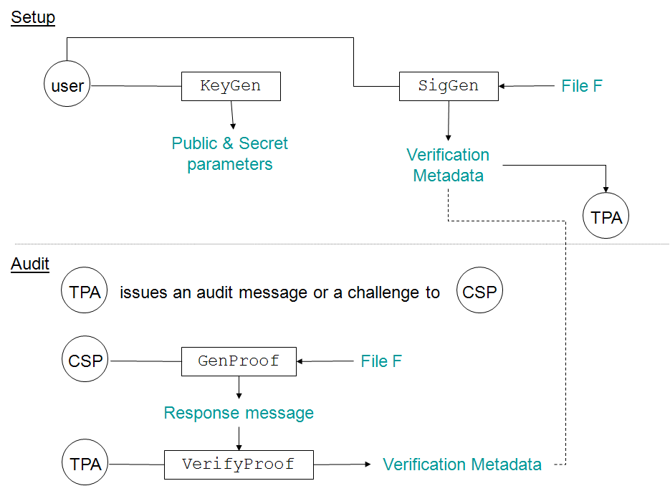

Modules:

- Public audit ability for storage correctness assurance:

To allow anyone, the clients who originally stored the file on cloud servers, to have the capability to verify the correctness of the stored data on demand.

- Dynamic data operation support:

To allow the clients to perform block-level operations on the data files while maintaining the same level of data correctness assurance. The design should be as efficient as possible so as to ensure the seamless integration of public auditability and dynamic data operation support.

- Blockless verification:

No challenged file blocks should be retrieved by the verifier (e.g., TPA) during verification process for efficiency concern.

- Dynamic Data Operation with Integrity Assurance:

Now we show how our scheme can explicitly and efficiently handle fully dynamic data operations including data modification (M), data insertion (I) and data deletion (D) for cloud data storage. Note that in the following descriptions, we assume that the file F and the signature _ have already been generated and properly stored at server. The root metadata R has been signed by the client and stored at the cloud server, so that anyone who has the client’s public key can challenge the correctness of data storage.

- Data Modification:
We start from data modification, which is one of the most frequently used operations in cloud data storage. A basic data modification operation refers to the replacement of specified blocks with new ones. At start, based on the new block the client generates the corresponding signature. The client signs the new root metadata R′ by sigsk(H(R′)) and sends it to the server for update. Finally, the client executes the default integrity verification protocol. If the
Output is TRUE, delete sigsk(H(R′)),and generate duplicate file.

- Batch Auditing for Multi-client Data:

As cloud servers may concurrently handle multiple verification sessions from different clients, given K signatures on K distinct data files from K clients, it is more advantageous to aggregate all these signatures into a single short one and verify it at one time. To achieve this goal, we
extend our scheme to allow for provable data updates and verification in a multi-client system. The signature scheme allows the creation of signatures on arbitrary distinct messages. Moreover, it supports the aggregation of multiple signatures by distinct signers on distinct messages into a single short signature, and thus greatly reduces the communication cost while providing efficient verification for the authenticity of all messages.

Algorithm Techniques:

- Setup Phase
- Audit Phase

The client’s public key and private key are generated by invoking KeyGen(·). By running SigGen(·), the data file F is pre-processed, and the homomorphic authenticators together with metadata are produced.
KeyGen(1k). The client generates a random signing key pair (spk, ssk). Choose a random α ← Zp and compute v ← gα. The secret key is sk = (α, ssk) and the public key is pk = (v, spk).
SigGen(sk, F). Given F = (m1,m2 . . . ,mn), the client chooses a random element u ← G. Let t = name||n||u||SSigssk(name||n||u) be the file tag for F.
Then the client computes signature σi for each block mi (i = 1, 2, . . . , n) as σi ← (H(mi) · umi)α. Denote the set of signatures by _ = {σi}, 1 ≤ i ≤ n. The client then generates a root R based on the construction (pk, sk) ← KeyGen(1k). This probabilistic algorithm is run by the client. It takes as input security parameter 1k, and returns public key pk and private key sk.
(_, sigsk(H(R))) ← SigGen(sk, F). This algorithm is run by the client. It takes as input private key sk and a file F which is an ordered collection of blocks {mi}, and outputs the signature set _, which is an ordered collection of signatures {σi} on {mi}. It also outputs metadata-the signature sigsk(H(R)) of the root R of a Merkle hash tree. In our construction, the leaf nodes of the hashes of H(mi). (P) ← GenProof(F,_, chal). This algorithm is run by the server. It takes as input a file F, its signatures _, and a challenge chal. It outputs a data integrity proof P for the
blocks specified by chal.

System Configuration:-

H/W System Configuration:-

Processor - Pentium –III

Speed - 1.1 Ghz
RAM - 256 MB(min)
Hard Disk - 20 GB
Floppy Drive - 1.44 MB
Key Board - Standard Windows Keyboard
Mouse - Two or Three Button Mouse
Monitor - SVGA

S/W System Configuration:-

Operating System :Windows95/98/2000/XP
Application Server : Tomcat5.0/6.X
Front End : HTML, Java, Jsp
Scripts : JavaScript.
Server side Script : Java Server Pages.
Database : Mysql
Database Connectivity : JDBC.

CONCLUSION

We propose a privacy-preserving public auditing system for data storage security in Cloud Computing. We utilize the homomorphic linear authenticator and random masking to guarantee that the TPA would not learn any knowledge about the data content stored on the cloud server during the efficient auditing process, which not only eliminates the burden of cloud user from the tedious and possibly expensive auditing task, but also alleviates the users’ fear of their outsourced data leakage. Considering TPA may concurrently handle multiple audit sessions from different users for their outsourced data files, we further extend our privacy-preserving public auditing protocol into a multi-user setting, where the TPA can perform multiple auditing tasks in a batch manner for better efficiency. Extensive analysis shows that our schemes are provably secure and highly efficient.

